**Parameterization in Selenium**

**Parameterization in Selenium** is a process to parameterize the test scripts in order to pass multiple data to the application at runtime. It is a strategy of execution which automatically runs test cases multiple times using different values. The concept achieved by parameterizing the test scripts is called **Data Driven Testing**.

## Type of Parameterization in TestNG -

To make parameterization more clear, we will go through the parameterization options in one the most popular framework for Selenium Webdriver – **TestNG**.

There are **two ways** by which we can achieve parameterization in TestNG

1. With the help of **Parameters** **annotation** and **TestNG XML** file.
2. With the help of **DataProvider** annotation.

**NOTE:**In case if the parameter name is same in suite level and test level then test level parameter will get preference over suite level. So, in that case, all the classes inside that test level will share the overridden parameter, and other classes which are outside the test level will share suite level parameter.

Passing parameters in testing.xml

Calling the parameters

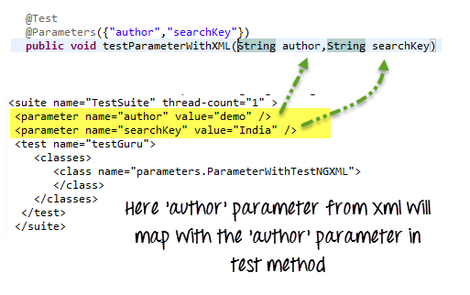

### Troubleshooting

**Issue # 1**Parameter value in testng.xml cannot be typecasted to the corresponding test method’s parameter it will throw an error.

Consider the following example

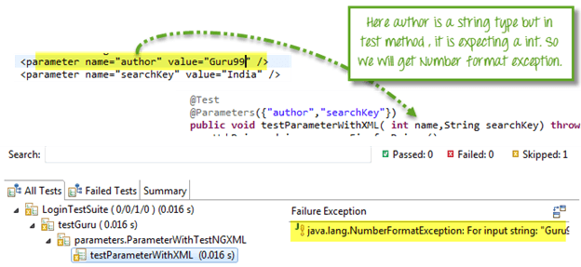

Here, ‘author’ attribute is equal to ‘Guru99’ which is a string and in corresponding test method its expecting an integer value, so we will get an exception here.

**Issue # 2**Your @Parameters do not have a corresponding value in testing.xml.

You can solve this situation by adding **@optional** **annotation** in the corresponding parameter in the test method.

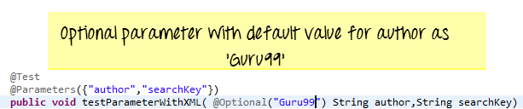

**Issue # 3:**You want to test multiple values of the same parameter using Testng.xml

The Simple answer is this can not be done! You can have multiple different parameters, but each parameter can only have a single value. This helps prevent hardcoding values into the script. This makes code reusable. Think of it as config files for your script. If you want to use multiple values for a parameter use DataProviders

**Summary**

* **Parameterization** is require to create **Data Driven Testing**.
* TestNG support two kinds of parameterization, using **@Parameter+TestNG.xml** and using**@DataProvider**
* In**@Parameter+TestNG.xml**parameters can be placed in suite level and test level. If

The Same parameter name is declared in both places; test level parameter will get preference over suit level parameter.

* using @Parameter+TestNG.xml only one value can be set at a time, but @DataProvider return **an 2d array of Object**.
* If DataProvider is present in the different class then the class where the test method resides,**DataProvider** should be **static method**.
* There are two parameters supported by **DataProvider** are **Method** and **ITestContext.**

https://www.guru99.com/parameterization-using-xml-and-dataproviders-selenium.html